**Experiment No.10**

**Aim:** Implementation of Josephus Problem using circular linked list.

Code:

/*

* C Program to Solve Josephus Problem using Linked List

*/

#include <stdio.h>

#include <conio.h>

#include <malloc.h>

struct node

{

int player_id;

struct node *next;

};

struct node *start,*ptr,*new_node;

int main()

{

int n,k,i,count;

printf("\n Enter the number of players:");

scanf("%d",&n);

printf("\n Enter the value of k:");

scanf("%d", &k);

start=malloc(sizeof(struct node));

start->player_id=1;

ptr=start;

for(i=2;i<=n;i++)

{

new_node=malloc(sizeof(struct node));

ptr->next=new_node;

new_node->player_id=i;

new_node->next=start;

ptr=new_node;

}

for(count=n;count>1;count--)

{

for(i=0;i<k-1;++i)

ptr=ptr->next;

printf("%d Deleted \n",ptr->next->player_id);

ptr->next=ptr->next->next;

}

printf("\n The winner is playeer: %d",ptr->player_id);

return 0;

}

Output:

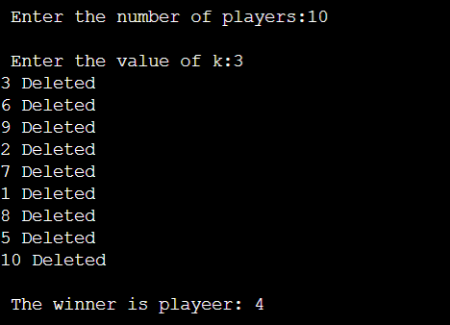

**Conclusion: -**

Thus in this experiment we implemented Josephus Problem using circular linked list.